**SUPER RESOLUTION MAPPING OF LAND COVER CLASSES**

by

**P.Naveen Raj - 2009115061**

**Yashwanth Kumar - 2009115117**

**S.B.Yuvaraja – 2009115118**

*A project report submitted to the*

**FACULTY OF INFORMATION AND COMMUNICATION ENGINEERING**

*in partial fulfillment of the requirements*

*for the award of the degree of*

**BACHELOR OF TECHNOLOGY**

*in*

**INFORMATION TECHNOLOGY**



DEPARTMENT OF INFORMATION SCIENCE AND TECHNOLOGY

ANNA UNIVERSITY, CHENNAI - 600025

MAY 2013

**CERTIFICATE**

Certified that this project report titled “**SUPER RESOLUTION MAPPING OF LAND COVER CLASSES**” is the bonafide work of **P.Naveen Raj (2009115061), Yashwanth Kumar (2009115117), S.B.Yuvaraja (2009115118)** who carried out the project work under my supervision, for the fulfillment of the requirements for the award of the degree of Bachelor of Engineering in Information Technology. Certified further that to the best of my knowledge, the work reported herein does not form part of any other thesis or dissertation on the basis of which a degree or an award was conferred on an earlier occasion on these are any other candidates.

**Place:** Chennai **Dr. K. Vani** **Date:** 14/05/2013 Associate Professor,

Department of Information Science and Technology,

Anna University,

Chennai – 600025.

COUNTERSIGNED

Dr. A.Kannan

Head of the Department,

Department of Information Science and Technology,

Anna University Chennai,

Chennai – 600025.

**ACKNOWLEDGEMENT**

We express our deep gratitude to our guide, **Dr. K.Vani** for guiding us through every phase of the project. We appreciate her thoroughness, tolerance and ability to share her knowledge with us. We thank her for being easily approachable and quite thoughtful. Apart from adding her own input, she has encouraged us to think on our own and give form to our thoughts. We owe her for harnessing our potential and bringing out the best in us. Without her immense support through every step of the way, we could never have it to this extent. We are extremely grateful to **Dr.A.Kannan**, Head of the Department of Information Science and Technology, Anna University, Chennai 600025, for extending the facilities of the Department towards our project and for his unstinting support. We express our thanks to the panel of reviewers **Dr.S.Swaminathan** , **Dr.K.Vidhya** and **Mrs.E.Uma and Dr.S.Senthil Kumar** for their valuable suggestions and critical reviews throughout the course of our project. We thank our parents, family, and friends for bearing with us throughout the course of our project and for the opportunity they provided us in undergoing this course in such a prestigious institution.

**P.Naveen Raj Yashwanth Kumar S.B.Yuvaraja**

**ABSTRACT (ENGLISH)**

Satellite images usually cover large area that will have various classes (grass, land, buildings …etc.). So large area what contains various classes will be seen as the single pixel. So to obtain the exact location of the different classes in the single pixel this project is proposed and developed.

In the first phase of the project soft classification of the image is done. Soft classification is the identification of the spectral components of the image and various soft classified images for the different classes in the image are obtained.

In the second phase of the project each class image after soft classification is taken and SPSAM (Sub Pixel Spatial Attraction Mapping) is done using calculating Attraction between neighboring pixels after this correlation between sub pixels are calculated and PSO(Particle Swarm Optimization) is applied for each soft classified class image.

In the third phase of the project results of all the classes after PSO(Particle Swarm Optimization) is merged and after that ACO (Ant Colony Optimization) is applied for all the soft classified images and results of all the class images are combined .Results of the ACO(Ant Colony Optimization) and PSO(Particle Swarm Optimization) are compared.

**ABSTRACT (TAMIL)**

செயற்கைக்கோள் படங்கள் பொதுவாக பல்வேறு வகுப்புகள் (புல், நிலம், கட்டிடங்கள் ... முதலியன) வேண்டும் என்று பெரிய பகுதி மறைப்பதற்கு. பல்வேறு வகுப்புகள் கொண்டுள்ளது என்ன இவ்வளவு பெரிய பகுதியை ஒற்றை பிக்சல் பார்க்கப்படுகிறது. எனவே ஒற்றை பிக்சல் வெவ்வேறு வகுப்புகள் இந்த திட்டம் முன்மொழியப்பட்டது மற்றும் உருவாக்கப்பட்டுள்ளது சரியான இடம் பெற.

திட்டத்தின் முதல் கட்டம் படத்தை மென்மையான வகைப்பாடு செய்யப்படுகிறது. மென்மையான வகைப்பாடு பெறலாம் படத்தை வெவ்வேறு வகுப்புகளுக்கு படம் மற்றும் பல்வேறு மென் விளம்பரங்கள் படங்களை ஸ்பெக்ட்ரம் கூறுகளை அடையாளம் ஆகும்.

திட்டத்தின் இரண்டாவது கட்டத்தில் மென்மையான வகைப்பாடு பின்னர் ஒவ்வொரு வர்க்கம் படத்தை எடுத்து மற்றும் SPSAM (உப பிக்சல் சார் அட்ராக்சன் மேப்பிங்) துணை பிக்சல்கள் இடையே இந்த தொடர்பு பின்னர் அண்டை பிக்சல்கள் இடையே கணக்கிடும் வலிமை பயன்படுத்தி செய்யப்படுகிறது கணக்கிடப்படுகின்றன மற்றும் PSO (துகள் திரள் தேர்வுமுறை) செலுத்தப்படுகிறது ஒவ்வொரு மென்மையான விளம்பரங்கள் வர்க்கம் படம்.

PSO பின்னர் அனைத்து வகுப்புகள் திட்ட முடிவுகளை மூன்றாவது கட்டத்தில் (துகள் திரள் தேர்வுமுறை) இணைக்கப்பட்டது என்று ACO (எறும்பு கூட்ட தேர்வுமுறை) அனைத்து மென்மையான விளம்பரங்கள் படங்கள் மற்றும் அனைத்து வர்க்கம் படங்களை சேர்க்கலாம் முடிவு விண்ணப்பித்த பிறகு. முடிவுகள் ACO (எறும்பு கூட்ட தேர்வுமுறை) மற்றும் PSO (துகள் திரள் தேர்வுமுறை) ஒப்பிடும்போது

TABLE OF CONTENTS

TITLE PAGE NO.

CERTIFICATE ii

ACKNOWLEDGEMENT iii

ABSTRACT (ENGLISH) iv

ABSTRACT (TAMIL) v

LIST OF FIGURES viii

LIST OF TABLES ix

LIST OF ABBREVIATIONS x

1. INTRODUCTION 1

**1.1 PROBLEM DOMAIN** 1

**1.1.1 TYPES OF CLASSIFICATION** 1

**1.1.2 SUPER RESOLUTION MAPPING** 2

**1.2 SCOPE OF THE PROJECT** 3

**1.3 PROBLEM DEFINITION** 4

2. LITERATURE STUDY 5

**2.1 TWO STEP APPROACH** 5

**2.1.1 LINEAR UNMIXING MODEL** 5

**2.1.2 MAXIMUM SPATIAL DEPENDENCE MODEL** 5

**2.2 HOP-FIELD NEURAL NETWORK** 5

**2.3 PARTICLE SWARM OPTIMIZATION** 6

**2.3.1 SUB-PIXEL/PIXEL SPATIAL ATTRACTION MODEL (SPSAM)** 6

**2.3.2 POST-PROCESSING SPSAM RESULTS** 7

3. SYSTEM ARCHITECTURE 8

**3.1 SOFT CLASSIFICATION** 8

**3.2 SUB-PIXEL MAPPING** 8

4. ALGORITHM 9

**4.1 ALGORITHM FOR SUB-PIXEL MAPPING** 9

**4.1.1 SPATIAL DEPENDENCE THEORY** 10

**4.1.2 SUB-PIXEL / PIXEL SPATIAL ATTRACTION MODEL (SPSAM)** 10

**4.2 ALGORITHM FOR POST-PROCESSING ON SPSAM RESULTS** 12

**4.2.1 PIXEL SWAPPING ALGORITHM** 12

**4.2.2 AN OBJECTIVE FUNCTION** 13

**4.3 THE PARTICLE SWARM OPTIMIZATION ALGORITHM** 14

**4.3.1 GENERAL PSO ALGORITHM** 14

**4.3.2 PSO AFTER SPSAM PROCESS** 15

**4.4 ANT COLONY OPTIMIZATION** 19

5. IMPLEMENTATION AND RESULTS 20

**5.1 TEST CASE 1 (2 CLASS SYNTHETIC IMAGE)** 20

**5.1.1 PSO ALGORITHM** 21

**5.1.2 ANT COLONY OPTIMIZATION ALGORITHM** 22

**5.1.3 COMPARISON OF PSO AND ANT COLONY OPTIMIZATION ALGORITHM** 22

**5.2 TEST CASE 2 (3 CLASS SYNTHETIC IMAGE)** 23

**5.2.1 PSO ALGORITHM** 24

**5.2.2 ANT COLONY OPTIMIZATION ALGORITHM** 24

**5.2.3 COMPARISON OF PSO AND ANT COLONY OPTIMIZATION ALGORITHM** 24

**5.3 TEST CASE 3 (3 CLASS SATELLITE IMAGE)** 25

**5.3.1 PSO ALGORITHM** 27

**5.3.2 ANT COLONY OPTIMIZATION ALGORITHM** 28

**5.3.3 COMPARISON OF PSO AND ANT COLONY OPTIMIZATION ALGORITHM** 29

**5.4 TEST CASE 3 (4 CLASS SATELLITE IMAGE)** 29

**5.4.1 PSO ALGORITHM** 32

**5.4.2 ANT COLONY OPTIMIZATION ALGORITHM** 33

**5.4.3 COMPARISON OF PSO AND ANT COLONY OPTIMIZATION ALGORITHM** 34

6. CONCLUSION 35

**6.1 FUTURE WORK AND OPTIMIZATION** 35

7. REFERENCES 36

**LIST OF FIGURES**

**FIGURE NO. TITLE PAGE NO.**

1. 1 Difference between Hard and Soft Classification 2

1. 2 A Mixed Pixel 3

2. 1 Super Resolution Mapping using HNN 8

3. 1 Block Diagram of Soft Classification 11

3. 2 The Block Diagram of Sub-Pixel Mapping with SPSAM and PSO 12

4. 1 Demonstration of Spatial Dependence Theory 14

4. 2 Flow Chart of PSO Algorithm 24

5. 1 Two Class Synthetic Image as Input (70x70) 26

5. 2 Presence of Class 1 (Yellow) 27

5. 3 Presence of Class 1 (Blue) 27

5. 4 Result of two class synthetic image after applying PSO Algorithm 28

5. 5 Result of two class synthetic image after applying ACO Algorithm 28

5. 6 Three Class Synthetic Image as Input (10x10) 29

5. 7 Presence of Class 1 (Black) 30

5. 8 Presence of Class 1 (Blue) 30

5. 9 Presence of Class 1 (White) 30

5. 10 Result of three class synthetic image after applying PSO Algorithm 31

5. 11 Result of three class synthetic image after applying ACO Algorithm 31

5. 12 Three Class Satellite Image as Input (227x216) 32

5. 13 Presence of Class 1 (Building) 33

5. 14 Presence of Class 2 (Grass) 34

5. 15 Presence of Class 3 (Land) 34

5. 16 Result of three class satellite image after applying PSO Algorithm 35

5. 17 Result of three class satellite image after applying ACO Algorithm 36

5. 18 Four Class Satellite Image as Input (187x195) 37

5. 19 Presence of Class 1 (Dark Blue) 38

5. 20 Presence of Class 2 (Blue) 38

5. 21 Presence of Class 3 (Orange) 39

5. 22 Presence of Class 4 (Red) 39

5. 23 Result of Four class satellite image after applying PSO Algorithm 40

5. 24 Result of four class satellite image after applying ACO Algorithm 42

**LIST OF TABLES**

**TABLE NO. TITLE PAGE NO.**

5. 1 Comparison of PSO And ACO Algorithm for SRM 34

**LIST OF ABBREVIATIONS**

PSO Particle Swarm Optimization

SPSAM Sub Pixel Spatial Attraction Mapping

ACO Ant Colony Optimization

MSI Multi Spectral Image

SPM Sub Pixel Mapping

SRM Super Resolution Mapping

**1. INTRODUCTION**

**1.1 PROBLEM DOMAIN**

Maps are classified based on images taken from satellite. This is a very complex task and involves many chances of errors. If the sensor is capable of only taking low resolution images (for example: 72 meters per pixel), then the mapping process becomes tedious.

**1.1.1 TYPES OF CLASSIFICATION**

There are two types of classification,

* + - Hard Classification and
    - Soft Classification.

**HARD CLASSIFICATION**

This is an approximate classification. This kind of classification maps one pixel to only a single color (or) to only a single land cover class. But this kind of classification suffers from some serious disadvantages.

If the satellite image is of poor resolution, then we cannot map a single pixel to exactly a single class. Consider for example, a poor resolution map of 73 meters per pixel. This pixel which covers an area of 72x72 square meters may not have only one land cover class. It is possible that it may contain mixed land cover classes.

**SOFT CLASSIFICATION**

In this kind of classification an accurate map can be obtained. This method finds out the area proportion of each land cover class in a particular pixel. Using that proportion we can be able to generate an accurate land cover map. This classification addresses the disadvantages of Hard Classification.



(a) (b) (c)

Figure 1. 1 Difference between Hard and Soft Classification

Figure 1.1 – (a) is the original synthetic image. Figure 1.1 – (b) is the Hard Classified image and Figure 1.1 – (c) is the Soft Classified image.

**1.1.2 SUPER RESOLUTION MAPPING**

Super-resolution mapping is a technique which allows mapping at the sub-pixel scale. Each pixel in the original satellite imagery is scaled by a scale factor and then the map is constructed. The soft classified image is fed as input to an Super Resolution Mapping (SRM) Algorithm. Using the percentage of land cover class present in each pixel, the exact spatial location of the land cover within the pixel is found. Various methods and algorithms have been adopted to produce SRMed image with more accuracy.

Several Super Resolution mapping techniques have been proposed such as spatial dependence maximization (Atkinson, 1997), sub-pixel per-classification (Aplin and Atkinson, 2001), linear optimization technique (Verhoeye and De Wulf, 2002), Hopfield neural network (Tatem et al., 2001a; Tatem et al., 2001b; Tatem et al., 2002), two-point histogram optimization (Atkinson, 2008), genetic algorithms (Mertens et al., 2003), wavelet coefficients prediction using feed-forward neural networks (Mertens et al., 2004) and pixel swapping (Thornton et al., 2006).

**SPECTRAL UNMIXING**



Figure 1. 2 A Mixed Pixel

In a mixed pixel, there may be many land cover classes present. The Fraction of these classes is identified by a technique called Spectral Unmixing.

In Figure 1.2, the entire box represents one pixel. This pixel has three land cover classes, black, blue and grey. Black occupies 25% of the space while Grey occupies 35% of the entire space and the remaining 40% is represented by Blue class. This fractional image is identified by this Spectral Unmixing process. This process just identifies the fraction of land cover classes and not the spatial location of them.

**SUB-PIXEL MAPPING**

Sub-pixel mapping (SPM) is a technique to predict spatial locations of land cover classes within mixed pixels in remotely sensed imagery. After the spectral unmixing process, the fraction image is fed into an algorithm for sub-pixel mapping. Then the algorithm makes an optimal arrangement of these fractional classes in that particular pixel.

**1.2 SCOPE OF THE PROJECT**

The Scope of the project includes soft classifying a given satellite imagery, then sub-pixel mapping it and then finally obtaining a super resolved image.

**Soft Classification**

-ENVI Tool.

**Sub-Pixel Mapping**

-PSO Algorithm.

-Ant Colony Optimization.

**Comparison of PSO and Ant Colony Optimization Algorithms**.

**1.3 PROBLEM DEFINITION**

The Satellite image obtained from a poor sensor is low in resolution (eg. 72*72 meters per pixel). In such images many information are lost. A single pixel can be represented using a single color only. But this is not the case in real time. A 72 square meter area may not contain a single class (A particular land cover), instead it may contain many classes like building, farms, lakes, rivers, grass lands etc.

Also Super Resolution Mapping of extremely large images can take more time. Say for example a 120x120 image can take at most 5 hours to complete.

**2. LITERATURE STUDY**

A Number of Approaches has been adopted for the problem of Super Resolution Mapping. Among those the following have been studied and referred.

**2.1 TWO STEP APPROACH**

The two-step approach first estimates fraction images by spectral unmixing and then inputs fraction images into an SPM algorithm to generate the final sub-pixel land cover map. A shortcoming of this approach is that the information about the credibility of fraction images is not considered. In this letter, we proposed a general framework of SPM which is directly applied to original coarse resolution remotely sensed imagery by integrating spectral and spatial information. Based on the proposed framework, the linear unmixing model and the maximal spatial dependence model were combined to construct a novel SPM model aiming to minimize the least squares error of spectral signature and make the sub-pixel land cover map spatially smooth, simultaneously.

**2.1.1 LINEAR UNMIXING MODEL**

In general, LUM views spectral signatures of each mixed pixel as being made up of a weighted linear sum of spectral signatures of end members within that pixel. The weights are determined by the relative area proportions of each end member.

**2.1.2 MAXIMUM SPATIAL DEPENDENCE MODEL**

This methodology aims to minimize a weighted sum of Spectral and Spatial terms. Maximizing the land cover spatial dependence is identical to making the resulting land cover map spatially smooth. Using both the spectral and spatial terms the proper arrangement of classes inside a pixel is identified.

**2.2 HOP-FIELD NEURAL NETWORK**

This process is an iterative approach to spectrally map a particular region. Figure 2.1 is a graphical depiction of the method proposed for incorporating a PAN image into super-resolution mapping using a HNN. A proportion image is obtained by Soft Classification and the proportion image is fed to a Hop-Field Neural Network (HNN). The proportion images are then used to produce the sub-pixel land-cover class at the first iteration using the HNN (each sub-pixel is represented by a neuron in the HNN). From the super-resolution map at the first iteration, an estimated MS image (at the PAN image spatial resolution) is then produced using a forward model and spatial convolution. The estimated MS image is then convolved spectrally to create a synthetic PAN image. By comparing the observed and synthetic PAN images, a value is produced for all neurons covered by the same pixel in the PAN image to make the synthetic PAN converge to the observed PAN image.

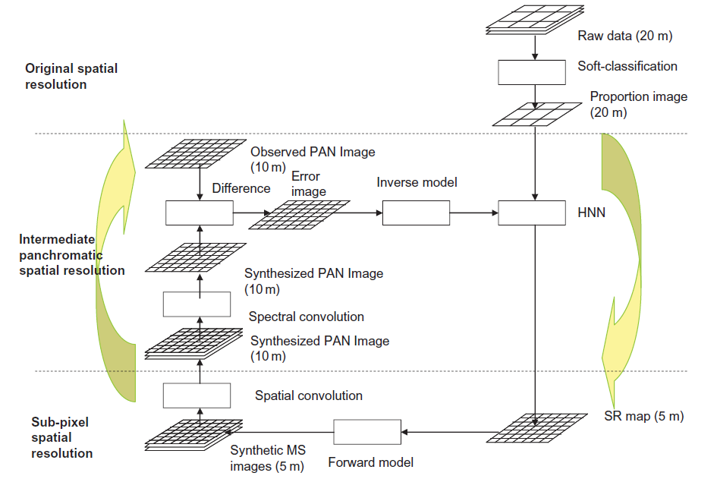

Figure 2. 1 Super Resolution Mapping using HNN

**2.3 PARTICLE SWARM OPTIMIZATION**

**2.3.1 SUB-PIXEL/PIXEL SPATIAL ATTRACTION MODEL (SPSAM)**

This Algorithm directly estimates the spatial location of a mixed pixel. It uses the attraction between sub-pixels and it’s neighboring pixels. As such, the algorithm requires no iteration to achieve the spatial allocation of sub-pixel classes. The advantage of this algorithm is that it is suitable for real-time processing. Particularly, when dealing with situations involving a large scale factor, it is fast in obtaining the SPM results. However, the algorithm fails to consider adequately the correlation between sub-pixels. When the scale factor is large, there can be many isolated pixels and much noise. If we apply the algorithm to real remote-sensing imagery, where the spatial distribution of each class is diverse and changeable, there may be many saw tooth shaped edges in the SPM results.

**CONCOCTION**

**Particle Swarm Optimization** (PSO) is a computational method that optimizes a problem by iteratively trying to improve a candidate solution with regard to a given measure of quality. PSO optimizes a problem by having a population of candidate solutions, here dubbed particles, and moving these particles around in the search-space according to simple mathematical formulae over the particle's position and velocity. Each particle's movement is influenced by its local best known position and is also guided toward the best known positions in the search-space, which are updated as better positions are found by other particles. This is expected to move the swarm toward the best solutions.

**2.3.2 POST-PROCESSING SPSAM RESULTS**

We can see that the SPSAM algorithm directly estimates the class of sub-pixels according to the class proportion of its neighboring pixels. However, the algorithm fails to adequately consider the correlation between sub-pixels, and thus it may lead to poor performance for SPM. The following methods can be used to post-process.

* + - Pixel Swapping Algorithm.
    - An Objective Function.
    - Particle Swapping Optimization Algorithm

In this project PSO Algorithm is used to post process SPSAM results.

**3. SYSTEM ARCHITECTURE**

**3.1 SOFT CLASSIFICATION**

Figure 3.1 depicts the architecture of the first step in the two step process, Soft Classification (or) Spectral Unmixing.

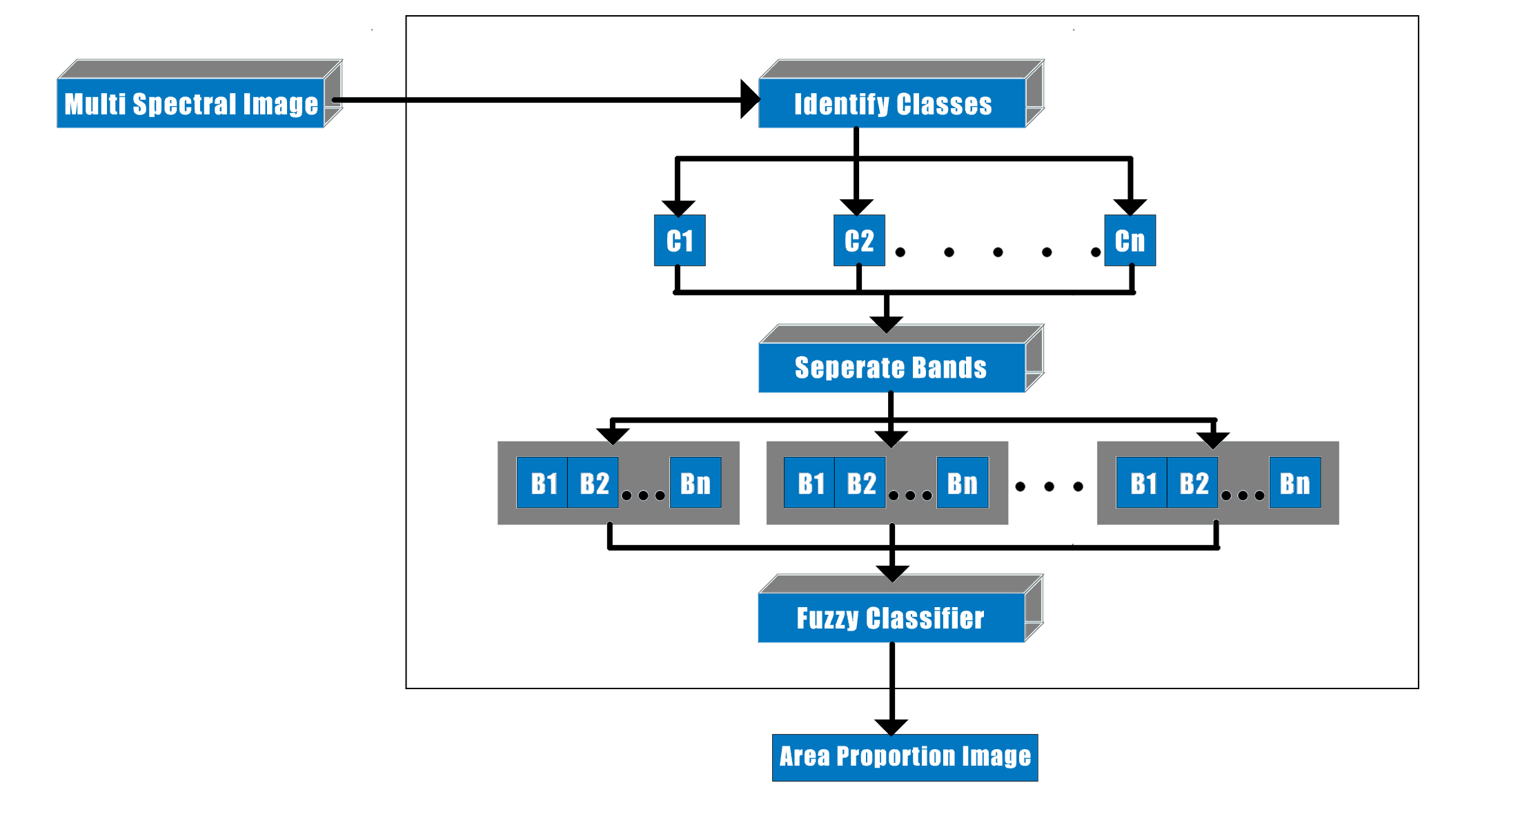

Figure 3. 1 Block Diagram of Soft Classification

The Multi Spectral (MS) Image is given as input for the Soft Classification Algorithm and an Area Proportion Image is obtained as output. In the first step of Soft Classification the classes are identified and then separated. In the next step, for each class bands are separated and given as input to a Fuzzy Classifier. This identifies the proportion of a particular class in a particular pixel. Thus the Area Proportion Image is obtained for each class. The Area Proportion image is a monochromatic image with white representing the complete presence of the class and black being the complete absence of the class.

**3.2 SUB-PIXEL MAPPING**

Figure 3.2 depicts the architecture diagram of the second step of the two step process, Sub-Pixel Mapping.

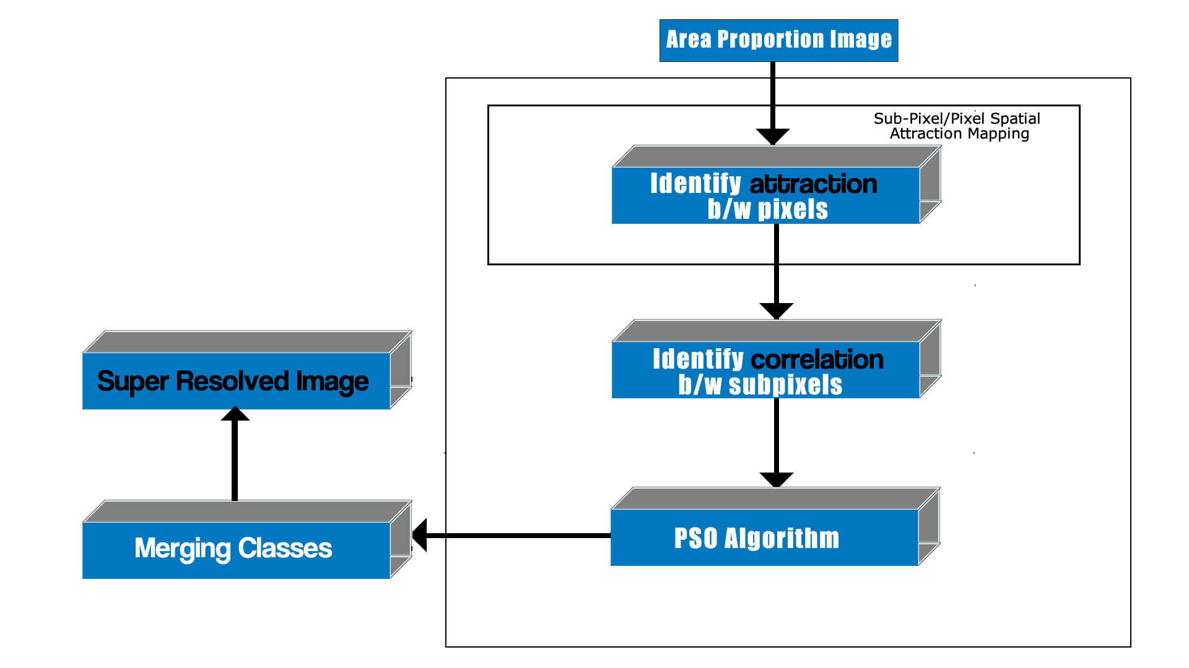

Figure 3. 2 The Block Diagram of Sub-Pixel Mapping with SPSAM and PSO

The Area Proportion image obtained from the soft classification process is the input for Sub-Pixel Mapping. The output is the final Super Resolved Image. In this Particle Swarm Optimization Algorithm is used along with SPSAM process to spatially identify the classes.

**4. ALGORITHM**

There are three algorithms uses in this project, one for Sup-Pixel Mapping and the two others for post-processing on the results obtained from Sub-Pixel Mapping.

**4.1 ALGORITHM FOR SUB-PIXEL MAPPING**

Atkinson (1997) initially proposed the concept of SPM and the spatial dependence theory with the assumption that land cover is spatially dependent both within and between pixels; that is, compared with distant pixels, neighboring pixels are more likely to be of the same land-cover class. Mertens *et al*. (2006) applied a Sub-Pixel/Pixel Spatial Attraction model (SPSAM) that realized the spatial dependence theory directly. This SPSAM is used in this project.

**4.1.1 SPATIAL DEPENDENCE THEORY**

A simple representation of SPM is given in figure 4.1. It shows a raster grid of 3 × 3 coarse spatial resolution pixels with associated proportions of one land-cover class in figure 4.1(*a*), which can be obtained by spectral unmixing. A single coarse resolution pixel is divided into 2 × 2 sub-pixels, each corresponding to a 25% area of coarse low-resolution pixels. From the proportions, the number of sub-pixels belonging to this class can be calculated.

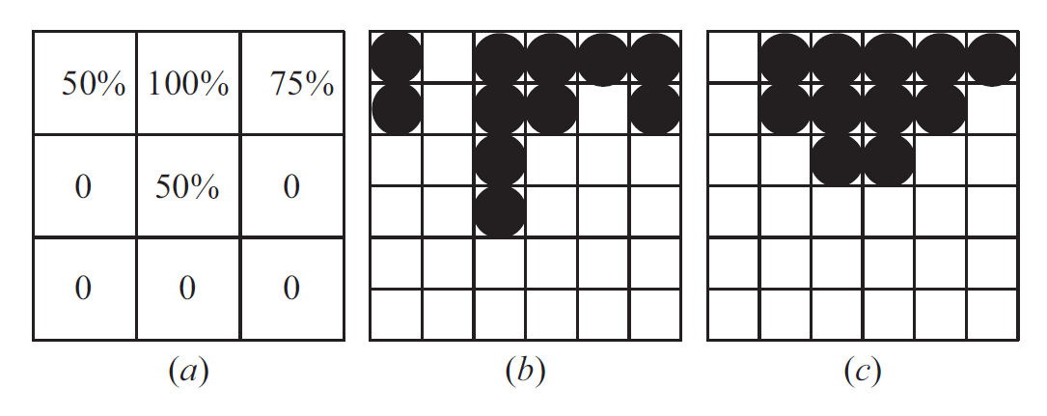

Figure 4. 1 Demonstration of Spatial Dependence Theory

For example, the fraction of 75% corresponds to three sub-pixels. One possible arrangement is shown in figure 4.1(*b*), where the black circles represent sub-pixels of the class. Obviously, its spatial structure conflicts with expectations of spatial dependence. This is because, in nature, the land cover coming from the same classes is more likely to stay together. Another solution is presented in figure 4.1(*c*). It can be seen that, compared with figure 4.1(*b*), the spatial dependence both within and between the coarse pixels in figure 4.1(*c*) is much stronger. Therefore, figure 4.1(*c*) is a more reasonable SPM result.

**4.1.2 SUB-PIXEL / PIXEL SPATIAL ATTRACTION MODEL (SPSAM)**

Mertens *et al*. (2006) applied SPSAM and realized the spatial dependence theory in a simple and effective way. In SPSAM, attractions between each sub-pixel within a coarse resolution pixel and its neighbour pixels are calculated in order to determine the spatial distribution of sub-pixels per class. Assume p*ij* is a sub-pixel in pixel P*ab* and P*k* is one of P*ab*’s neighbors. Then the attraction from class *c* for sub-pixel p*ij* is calculated as

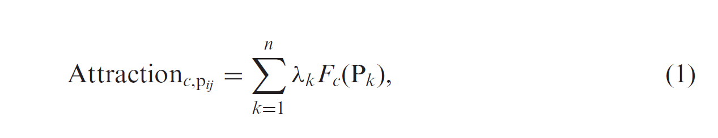

where *n* is the total number of neighbors (in this article, *n* is set to 8) and *Fc*(P*k*) is the fraction value of the *k*th neighboring pixel P*k* for class *c*. *λk* is the measurement of spatial dependence and is calculated as

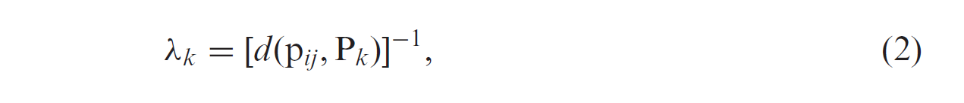

where *d*(p*ij*, P*k*) is the Euclidean distance between geometric centers of sub-pixel p*ij* and its neighboring pixel P*k* and is calculated as

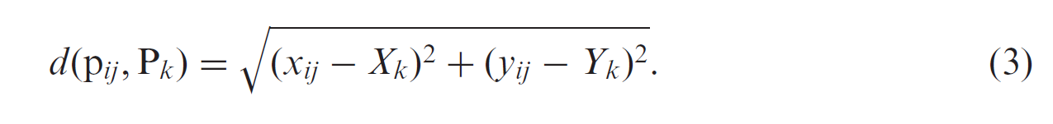

Finally, Attraction*c*,p*ij* for each class can be used for the assignment of sub-pixels to the different classes: sub-pixels with highest attractions are assigned first. The SPSAM algorithm is much easier for the situation of two land-cover classes. Suppose there are two classes A and B. We can conduct the SPSAM as follows: within a coarse resolution pixel P*ab*, each p*ij*’s Attraction*c*,p*ij* is first calculated by equations (1)–(3) and then the values are ranked in order. Finally, the *F*A(P*ab*) *S*2 (*F*A(P*ab*) is the fraction value of class A within pixel P*ab* and *S* is a scale factor) sub-pixels with high values of Attraction*c*,p*ij* are assigned to class A while the residual ones are assigned to class B (Mertens *et al*. 2004). This approach can also be extended to multiple classes.

**4.2 ALGORITHM FOR POST-PROCESSING ON SPSAM RESULTS**

We can see that the SPSAM algorithm directly estimates the class of sub-pixels according to the class proportion of its neighboring pixels. However, the algorithm fails to adequately consider the correlation between sub-pixels, and thus it may lead to poor performance for SPM. Shen *et al* (2009) adopted a method that created a modified pixel-swapping algorithm (MPS) with initialization from SPSAM. Although its original purpose was to improve the PSA, it can be regarded as a method that enhances the performance of SPSAM as well by fully considering the correlation between sub-pixels after SPSAM. In this section, the principle of PSA is described first, and then an objective function is proposed based on this principle. The objective function will be used for the searching process by PSO in the next section and will also be used as a post-processing method after the SPSAM procedure.

**4.2.1 PIXEL SWAPPING ALGORITHM**

Atkinson (2001, 2005) proposed the PSA. The objective was to vary the spatial arrangement of the sub-pixels in such a way that the spatial correlation between neighboring sub-pixels (both within and, perhaps more importantly, between pixels) would be maximized. Two classes are taken into account: ‘1’ and ‘0’. For each sub-pixel p*ij* , the attraction caused by all its neighboring sub-pixels is calculated as

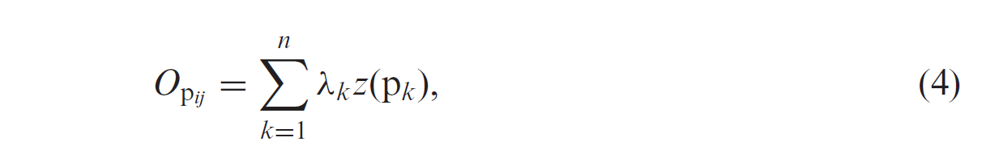

where *n* is the total number of neighbors, *z*(*pk*) is the binary value of the class for p*k* and *λs* is the measurement of spatial correlation between sub-pixels and is calculated as

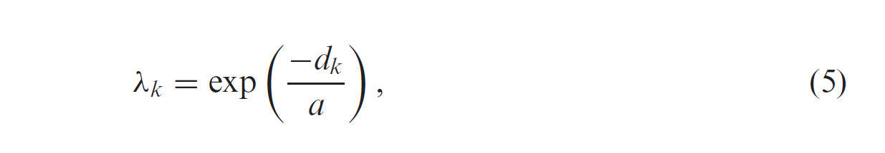

where *a* is a non-linear parameter of the exponential model and *dk* is the Euclidean distance between geometric centers of sub-pixel p*ij* and its neighboring sub-pixel p*k*, as in equation (3). We can see that *O*p*ij* indicates the attraction for p*ij* caused by class ‘1’ from its neighboring sub-pixels. After each p*ij*’s *O*p*ij* has been calculated, the following two-stage process is conducted for each pixel P*ab*:

**Stage 1:** Rank all *O*p*ij* in decreasing order. As a result, a corresponding sequence (sequence*a*) is generated, which is composed of the binary values of the class for p*ij* .

**Stage 2:** Identify the first ‘0’ from left and the first ‘1’ from right in the sequence. If the ‘0’ locates before the ‘1’, then the two values are swapped to increase the total attraction inside P*ab*. Otherwise, no change is made.

The above two-stage process is repeated iteratively. The process can be stopped either at a fixed number of iterations or when little change is made. PSA was first used to work for two classes. It can be extended for multiple classes.

**4.2.2 AN OBJECTIVE FUNCTION**

Having studied the feature of sequence*a*, we can construct an objective function that makes the correlation between sub-pixels reach maximum after the SPSAM process. Again the two classes are regarded: ‘1’ and ‘0’, i.e. p*ij* takes 1 or 0 for an unmixed pixel P*ab*. The objective function with the constraint condition can be written as

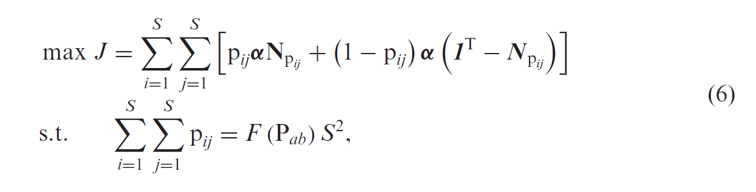

where F(P*ab*) is the proportion of class ‘1’ in P*ab* and **N**p*ij* is a vector composed of the class values of p*ij*’s neighboring sub-pixels: **N**p*s*=[p*i*−1,*j*−1, p*i*−1,*j*, p*i*−1,*j*+1, p*i*,*j*−1, p*i*,*j*+1, p*i*+1,*j*−1, p*i*+1,*j*, p*i*+1,*j*+1]T. It should be noticed that when *i* = 1 or *j* = 1, the subscript of some of **N**p*ij’s* elements is equal to 0. *dk* (*k* = 1, 2, *. . .* , 8) is the distance between p*ij* and the *k*th neighboring sub-pixel. **1**T is a vector composed of elements of 1’s. If p*ij* belongs to class ‘1’ (p*ij* = 1), the attraction for the sub-pixel caused by ‘1’ from its neighbors can be calculated by the first term of equation (6). In contrast, if p*ij* belongs to class ‘0’ (p*ij* = 0), the attraction for the sub-pixel caused by ‘0’ from its neighbors can be calculated by the second term of equation (6). As a result, inside P*ab*, the total attraction for all of the sub-pixels caused by the same class can be calculated by equation (6).When the correlation between sub-pixels is maximized, Jreaches maximum. Hence, by solving equation (6), we can get the most suitable distribution of all sub-pixels within the mixed pixel by evaluating all possible configurations and selecting the one that makes Jreach maximum. However, it mainly works well for small images with a small scale factor (Mertens *et al*. 2003b). With a large scale factor, the number of combinations of possible spatial distribution increases dramatically and the computational load may become unrealistic. For this reason, there is a need to introduce an effective optimization algorithm to handle the problem. So a PSO technique is used in this project and it is discussed in detail in the next section.

**4.3 THE PARTICLE SWARM OPTIMIZATION ALGORITHM**

**4.3.1 GENERAL PSO ALGORITHM**

The initial PSO is operated in the continuous-valued space, where coordinates for every particle’s position and velocity are coded as real numbers in each dimension. The PSO algorithm that operates on discrete binary variables is Binary PSO. In the binary PSO, coordinates for position will take on a 1 or 0 value, but it is not for velocity. The mathematical description of the binary PSO is as follows. Each particle *i* consists of two vectors, position and velocity, which can be represented by **X***i* = [*Xi*1, *Xi*2, *. . .* , *Xim*] and **V***i* = [*Vi*1, *Vi*2, *. . .* , *Vim*], respectively, where *m* is the dimension of the search space. One position vector **X***i* corresponds to one solution to the optimization problem. The position and velocity are updated as

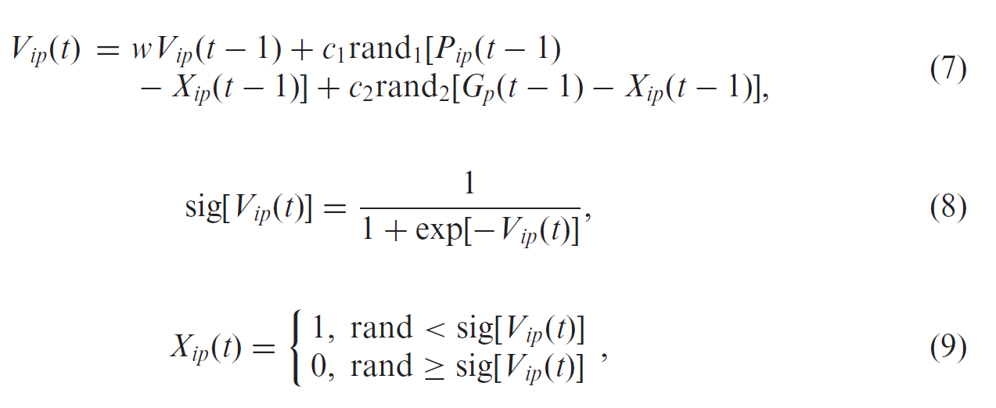

where *i* = 1, 2, *. . .* , *M*, with *i* representing the ith particle and *M* the size of the swarm; *t* is the number of generations; sig means sigmoid function; *V*ip(t) and *X*ip(t) mean the coordinate values of the *p*th dimension of velocity **V**iand the *p*th dimension of spatial position ***X****i* at the tth generation; *Pip*(*t* – 1) is the coordinate value of the *p*th dimension of ***P***i(*t* – 1) that indicates the best solution for particle *i* from the first to the (*t* – 1)th generation; *Gp*(*t* – 1) is the coordinate value of the *p*th dimension of **G**(*t* – 1) that indicates the best position or solution in the whole swarm during the (*t* – 1)th generation; *w* is the inertia weight coefficient; *c*1 and *c*2 are learning rates, that is they are non-negative constants and usually both are set to 2; and rand1 and rand2 are independent random numbers between 0 and 1.

**4.3.2 PSO AFTER SPSAM PROCESS**

At first, the correspondence between the position of a random particle and its solution is illustrated in figure 3, where the scale factor *S* = 3. Then, suppose the SPM result SuperA is acquired by the SPSAM procedure and

PSO is implemented after it, with the whole process executed as follows.

**Stage 1:** A mixed pixel P*ab* in a coarse low-resolution image (i.e. fraction image) is selected in order and the following six steps of processing are carried out.

Step 1. A swarm with *M* particles is formed with the dimension number *S*2 for each particle *i*, *i* = 1, 2, *. . .* , *M*. Necessarily, the total number (defined as *Ni*) of sub-pixels that belong to class 1 must be *F*(P*ab*)*S*2. For a mixed pixel P*ab*, a certain particle can be extracted from SuperA, the position of which corresponds to the spatial distribution of the classes in P*ab* itself. After that, the particular particle is cloned several times. Assume *ρ*clone ∈ (0,1) is the defined ratio. As a result, there will be *ρ*clone*M* clones generated in the swarm. *ρ*clone cannot be too high, otherwise it will result in premature convergence and will fall into local optima.

**Step 2:** The initialization of the velocity for every particle: ***V****i* = [*Vi*1, *Vi*2, *. . .* , *V­*], *i* = 1, 2, *. . .* , *M*, where the *p*th dimension of the *i*th particle is initialized as



We can set *V*min = –*V*max and then *Vip* is restricted to the interval [–*V*max, *V*max].

**Step 3:** According to equation (6), the fitness *JXi* of each particle is calculated. Afterwards, the particle ***G***(*t*) that has the highest fitness is selected and it is just the best position in the whole swarm at the *t*th generation. Besides, the best position ***Pi***(*t*) for particle *i* from the first to the *t*th generation is also selected in the same way. By using equations (7)–(9), the position and velocity are updated, after which the velocity is restricted as

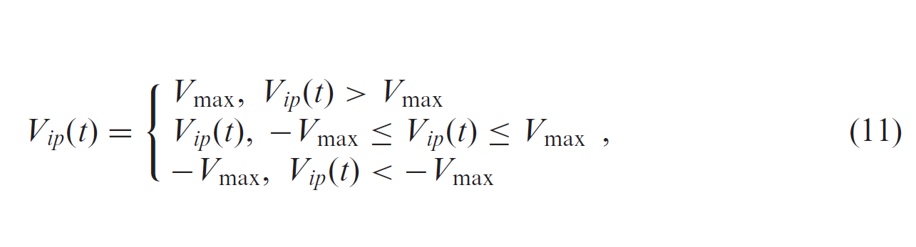

This can prevent the particles from falling into local optima and flying over the best position.

**Step 4:** The constraint in equation (6) is realized. After one update, *Ni* may not be F(P*ab*)*S*2 and measures should be taken to maintain the constraint, which can be realized as follows: if *Ni* is bigger than F(P*ab*)*S*2, *N*1 – F(P*ab*)*S*2 particles that belong to class ‘1’ are randomly selected and changed into ‘0’ while, on the contrary, the selected ones are change into ‘1’.

**Step 5:** Swarm goes through *R* times evolution according to steps 3 and 4.

**Step 6:** The best position *X*best during all generations is found out and used to re-decide the spatial distribution of the classes within P*ab* in SuperA.

**Stage 2**: For all mixed pixels in the fraction image, stage 1 is processed.

**Stage 3**: The behavior of the swarm is affected by sub-pixels that are part of neighboring coarse resolution pixels (i.e. p*kn*) and changes in one coarse resolution pixel should have an influence on neighboring coarse resolution pixels. Therefore, stages 1 and 2 are repeated *Q* times, and the SPM result SuperB based on PSO is approached iteratively. Figure 4.2 displays the whole PSO-based SPM process, where *r* and *h* denote the counters of generations and iterations, respectively. When the total number of classes is *C*, then we can construct *C* one-against-rest models. In each model, one class is selected as class ‘1’ and other classes are treated as class ‘0’.

Then the spatial distribution of class ‘1’ is determined. At last, *C* sub-pixel maps will be generated. Theoretically, the boundaries of each class within the coarse resolution pixel may compete with each other. An effective way to integrate the *C* sub-pixel maps and get the SPM results for multiple classes is to choose the boundary of each class as a common boundary in turn (Ge *et al*. 2009). For each coarse resolution pixel, once the first class is allocated in agreement with its boundary, only the remaining sub-pixels are used to allocate the second class in agreement with the boundary of this class. This ordered allocation procedure continues until the final class is allocated. In this way, the order of these classes must be specified at first. Makido *et al*. (2007) have advocated a method using Moran’s *I* to determine the order. However, this method requires prior class information, which is not obtainable in most real situations. To avoid complex procedures, here a simple and effective method is applied. Instead of starting to allocate sub-pixels of the dominant class surrounded by many neighbors, it may seem reasonable to first determine the distribution of the rare sub-pixels among them (Mertens *et al*. 2006). For this reason, for each selected coarse resolution pixel, the classes within it can be ranked according to their fractions from this pixel’s neighbors and the class with smaller fraction is allocated before the classes with larger fractions.

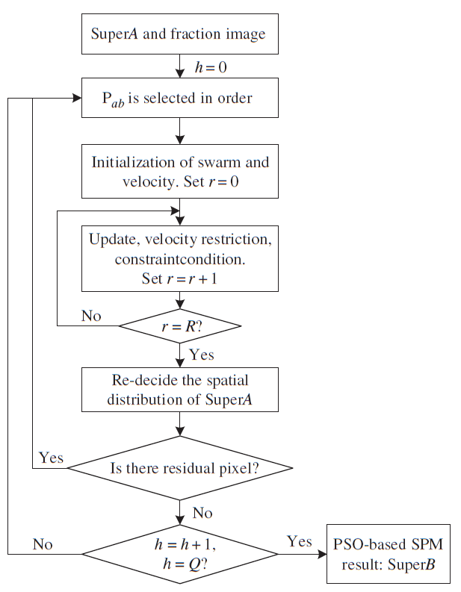

Figure 4. 2 Flow Chart of PSO Algorithm

**4.4 ANT COLONY OPTIMIZATION**

The **ant colony optimization** algorithm **(ACO)** is a probabilistic technique for solving computational problems which can be reduced to finding good paths through graphs.

This algorithm is a member of the **ant colony algorithms** family, in swarm intelligence methods, and it constitutes some metaheuristic optimizations. Initially proposed by Marco Dorigo in 1992 in his PhD thesis, the first algorithm was aiming to search for an optimal path in a graph, based on the behavior of ants seeking a path between their colony and a source of food. The original idea has since diversified to solve a wider class of numerical problems, and as a result, several problems have emerged, drawing on various aspects of the behavior of ants.

**5. IMPLEMENTATION AND RESULTS**

In this section we will compare the results of the PSO (Particle Swarm Optimization) and the Ant Colony Optimization technique, In general in the PSO Algorithm we are getting the better result than the ANT Colony Optimization technique because in the ANT Colony technique the ants position cannot be predicated accurately so we are choosing the ants initial position randomly.

Results of the PSO for the various input images (with different classes, Satellite image and synthetic image) are compared with the ANT Colony Optimization for the same image.

**5.1 TEST CASE 1 (2 CLASS SYNTHETIC IMAGE)**



Figure 5. 1 Two Class Synthetic Image as Input (70x70)

This is the input image that we are going to process using PSO Algorithm and ANT colony Optimization Algorithm , this image is created manually with 70*70 pixels with two colors yellow and blue , in this yellow is taken as the one class and blue is taken as another class.

**Image after Soft Classification:**

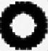

Figure 5. 2 Presence of Class 1 (Yellow)

This is the image that we obtain after the soft classification of our input image in this white represents the area where the yellow class is present and black represents the area where the yellow class is not present.

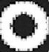

Figure 5. 3 Presence of Class 1 (Blue)

This is the image that we obtain after the soft classification of our input image in this white represents the area where the blue class is present and black represents the area where the blue class is not present.

**5.1.1 PSO ALGORITHM**

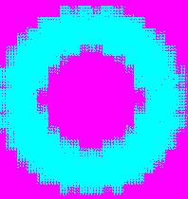

Figure 5. 4 Result of two class synthetic image after applying PSO Algorithm

The final image that is obtained is 210*210 because in this we used scale factor as 3, and this image is used to test the accuracy of the PSO because only in the synthetic image accuracy can be checked , in this the blue represents the area of the Dark Blue class and rose represents the yellow class areas.

**5.1.2 ANT COLONY OPTIMIZATION ALGORITHM**

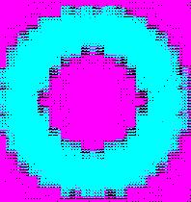

Figure 5. 5 Result of two class synthetic image after applying ACO Algorithm

The final image that is obtained is 210*210 because in this we used scale factor as 3, and this image is used to test the accuracy of the ANT Colony Optimization because only in the synthetic image accuracy can be checked, in this the blue represents the area of the Dark Blue class and rose represents the yellow class areas and black dots represents the unclassified classes.

**5.1.3 COMPARISON OF PSO AND ANT COLONY OPTIMIZATION ALGORITHM**

**SPEED**

As both the algorithms are ran using the parallel processing results are obtained quicker for the both the techniques but PSO took nearly of 20 sec to process this image and for ANT colony speed cannot be told accurately because speed depends upon the number of the Ants that are generated randomly.

**ACCURACY**

PSO is more accurate than the ANT colony Optimization technique because in the ANT colony Optimization technique we are getting some classified classes in the synthetic image itself but in the ANT Colony Optimization technique edge are clearer than the PSO algorithm.

**5.2 TEST CASE 2 (3 CLASS SYNTHETIC IMAGE)**



Figure 5. 6 Three Class Synthetic Image as Input (10x10)

This is the input image that we are going to process using PSO technique and ANT colony Optimization technique, this image is created manually with 10*10 pixels with three colors black, white and blue , in this black is taken as the one class , blue is taken as other class and white is taken as other class.

**Image after Soft Classification:**



Figure 5. 7 Presence of Class 1 (Black)

This is the image that we obtain after the soft classification of our input image in this white represents the area where the black class is present and black represents the area where the black class is not present



Figure 5. 8 Presence of Class 1 (Blue)

This is the image that we obtain after the soft classification of our input image in this white represents the area where the blue class is present and black represents the area where the blue class is not present



Figure 5. 9 Presence of Class 1 (White)

This is the image that we obtain after the soft classification of our input image in this white represents the area where the white class is present and black represents the area where the white class is not present

**5.2.1 PSO ALGORITHM**



Figure 5. 10 Result of three class synthetic image after applying PSO Algorithm

The final image that is obtained is 30*30 because in this we used scale factor as 3, and this image is used to test the accuracy of the PSO because only in the synthetic image accuracy can be checked, in this the yellow represents the area of the white class, rose represents the areas of dark blue class and blue represents the area of black class.

**5.2.2 ANT COLONY OPTIMIZATION ALGORITHM**



Figure 5. 11 Result of three class synthetic image after applying ACO Algorithm

The final image that is obtained is 30*30 because in this we used scale factor as 3, and this image is used to test the accuracy of the ANT Colony Optimization because only in the synthetic image accuracy can be checked, in this the green represents the area of the white class, rose represents the areas of dark blue class and yellow represents the area of black class.

**5.2.3 COMPARISON OF PSO AND ANT COLONY OPTIMIZATION ALGORITHM**

**SPEED**

As both the algorithms are ran using the parallel processing results are obtained quicker for the both the techniques but PSO took nearly of 5 sec to process this image and for ANT colony speed cannot be told accurately because speed depends upon the number of the Ants that are generated randomly

**ACCURACY**

PSO is more accurate than the ANT colony Optimization technique because in the ANT colony Optimization technique we are getting some classified classes in the synthetic image itself but in the ANT Colony Optimization technique edge are clearer than the PSO algorithm.

**5.3 TEST CASE 3 (3 CLASS SATELLITE IMAGE)**

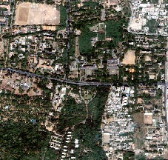

Figure 5. 12 Three Class Satellite Image as Input (227x216)

This is the input image that we are going to process using PSO technique and ANT colony Optimization technique, this image is satellite image with 227*216 pixels, in this 3 class is selected which represents the buildings , grass and land area.

**Image after Soft Classification:**

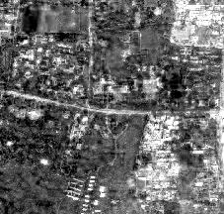

Figure 5. 13 Presence of Class 1 (Building)

This is the image that we obtain after the soft classification of our input image in this white represents the area where the building class is present and black represents the area where the building blue class is not present.

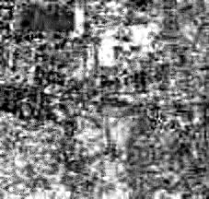

Figure 5. 14 Presence of Class 2 (Grass)

This is the image that we obtain after the soft classification of our input image in this white represents the area where the grass class is present and black represents the area where the building grass class is not present.

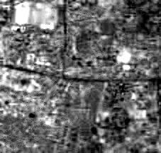

Figure 5. 15 Presence of Class 3 (Land)

This is the image that we obtain after the soft classification of our input image in this white represents the area where the land class is present and black represents the area where the building land class is not present.

**5.3.1 PSO ALGORITHM**

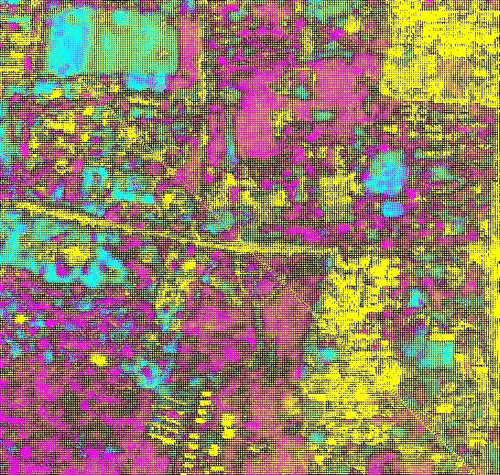

Figure 5. 16 Result of three class satellite image after applying PSO Algorithm

The final image that is obtained is 681*685 because in this we used scale factor as 3 , and this image is used to test the accuracy of the PSO because only in the synthetic image accuracy can be checked.

**5.3.2 ANT COLONY OPTIMIZATION ALGORITHM**

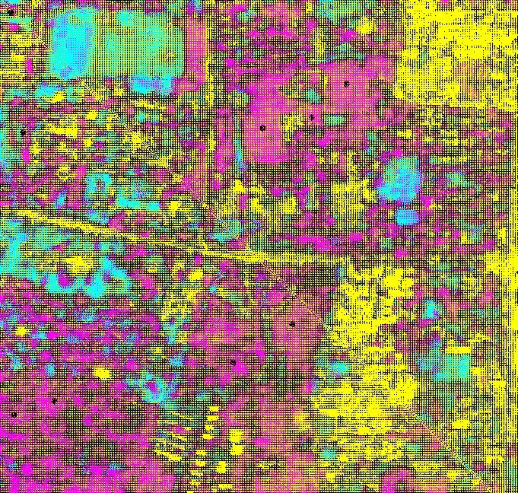

Figure 5. 17 Result of three class satellite image after applying ACO Algorithm

The final image that is obtained is 561*585 because in this we used scale factor as 3 , and this image is used to test the accuracy of the ANT Colony Optimization because only in the synthetic image accuracy can be checked, in this the yellow represents the building class, rose represents the area of grass class and blue represents the land area.

**5.3.3 COMPARISON OF PSO AND ANT COLONY OPTIMIZATION ALGORITHM**

**SPEED**

As both the algorithms are ran using the parallel processing results are obtained quicker for the both the techniques but PSO took nearly of 10 minutes to process this image and for ANT colony speed cannot be told accurately because speed depends upon the number of the Ants that are generated randomly.

**ACCURACY**

PSO is more accurate than the ANT colony Optimization technique because in the ANT colony Optimization technique we are getting some classified classes but in the ANT Colony Optimization technique edge are clearer than the PSO algorithm.

**5.4 TEST CASE 3 (4 CLASS SATELLITE IMAGE)**

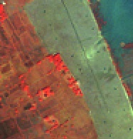

Figure 5. 18 Four Class Satellite Image as Input (187x195)

This is the input image that we are going to process using PSO technique and ANT colony Optimization technique, this image is satellite image with 187*195 pixels, in this 4 class is selected with the different colors.

**Image after Soft Classification:**

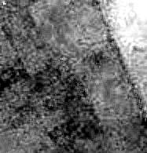

Figure 5. 19 Presence of Class 1 (Dark Blue)

This is the image that we obtain after the soft classification of our input image in this white represents the area where the dark blue class is present and black represents the area where the dark blue class is not present.

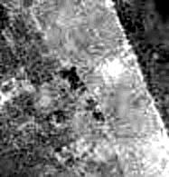

Figure 5. 20 Presence of Class 2 (Blue)

This is the image that we obtain after the soft classification of our input image in this white represents the area where the blue class is present and black represents the area where the blue class is not present.

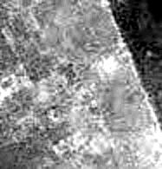

Figure 5. 21 Presence of Class 3 (Orange)

This is the image that we obtain after the soft classification of our input image in this white represents the area where the orange class is present and black represents the area where the orange class is not present.

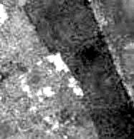

Figure 5. 22 Presence of Class 4 (Red)

This is the image that we obtain after the soft classification of our input image in this white represents the area where the red class is present and black represents the area where the red class is not present.

**5.4.1 PSO ALGORITHM**

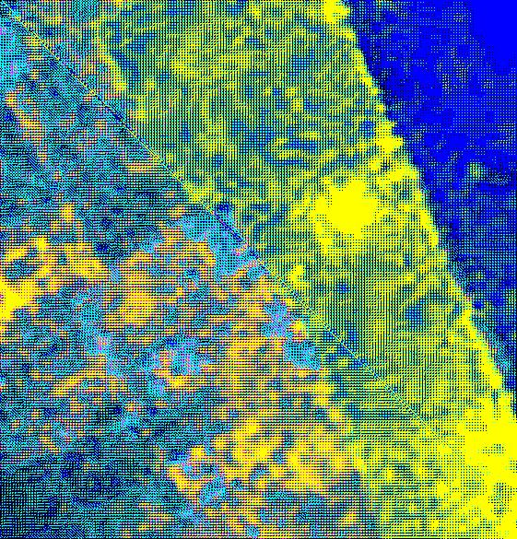

Figure 5. 23 Result of Four class satellite image after applying PSO Algorithm

The final image that is obtained is 561*585 because in this we used scale factor as 3, and this image is used to test the accuracy of the PSO because only in the synthetic image accuracy can be checked, in this the dark blue represents the area of the dark blue class, yellow represents the areas of blue class, dark yellow represents the area of red class and light blue represents the area of orange class.

**5.4.2 ANT COLONY OPTIMIZATION ALGORITHM**



Figure 5. 24 Result of four class satellite image after applying ACO Algorithm

The final image that is obtained is 561*585 because in this we used scale factor as 3 , and this image is used to test the accuracy of the ANT Colony Optimization because only in the synthetic image accuracy can be checked, in this the dark blue represents the area of the dark blue class , yellow represents the areas of blue class, dark yellow represents the area of red class and light blue represents the area of orange class.

**5.4.3 COMPARISON OF PSO AND ANT COLONY OPTIMIZATION ALGORITHM**

**SPEED**

As both the algorithms are ran using the parallel processing results are obtained quicker for the both the techniques but PSO took nearly of 5 sec to process this image and for ANT colony speed cannot be told accurately because speed depends upon the number of the Ants that are generated randomly.

**ACCURACY**

PSO is more accurate than the ANT colony Optimization technique because in the ANT colony Optimization technique we are getting some classified classes but in the ANT Colony Optimization technique edge are clearer than the PSO algorithm.

**5.5 GENERAL COMPARISON OF PSO AND ACO ALGORITHM**

|  |  |  |  |  |
| --- | --- | --- | --- | --- |
|  | **SPEED** | **UNCLASSIFIED** | **EDGES** | **Image Accuracy** |
| **PSO(Particle swarm Optimization)** | Fixed | Very less | Not accurate | 98% |
| **ACO(Ant Colony Optimization)** | Not fixed | More | Accurate | 85% |

Table 5. 1 Comparison of PSO And ACO Algorithm for SRM

**6. CONCLUSION**

In our research, we have explored on different techniques of sub-pixel mapping to help map an area. We have proposed a novel approach for post processing to enhance SPSAM process. We have compared two Optimization algorithms, the Particle Swarm Optimization and Ant Colony Optimization to efficiently map a particular area.

**6.1 FUTURE WORK AND OPTIMIZATION**

We are planning to try out many different optimization algorithms for effectively and efficiently produce mapping results. Comparing each of them with others reveals the best algorithm to be implemented in the Mapping Domain.

**7. REFERENCES**

* A. J. Tatem, H. G. Lewis, P. M. Atkinson, and M. S. Nixon, “Super-resolution land cover pattern prediction using a Hopfield neural network,” Remote Sens. Environ. , vol. 79, no. 1, pp. 1–14, Jan. 2002.
* Feng Ling, Yun Du, Fei Xiao, and Xiaodong Li“Subpixel Land Cover Mapping by Integrating Spectral and Spatial Information of Remotely Sensed Imagery” IEEE GEOSCIENCE AND REMOTE SENSING LETTERS., 2011 IEEE.
* P. M. Atkinson, “Issues of uncertainty in super-resolution m apping and their implications for the design of an inter-comparison study,” Int. J.Remote Sens., vol. 30, no. 20, pp. 5293–5308, Oct. 2009.
* A. J. Tatem, H. G. Lewis, P. M. Atkinson, and M. S. Nixon, “Super-resolution target identification from r emotely sensed images using a Hop-field neural network,” IEEE Trans. Geosci. Remote Sens. , vol. 39, no. 4, pp. 781–796, Apr. 2001.
* <http://en.wikipedia.org/wiki/Particle_swarm_optimization>
* <http://en.wikipedia.org/wiki/Ant_colony_optimization_algorithms>